Transfusion Service Test and Blood Component Request Form
For Lab Use Only  Patient History Check Tech  Y / N Patient >4 MONTHS  Ctrl+D Display ABO/RH: Y / N TYPEC Needed  ABORH:  Order # | SJCH/ART – Tube Station #55  Phone Number: 6-5656  Main Hospital – Tube Station #77  Phone Number: 2-2674 |  | Location Phone Ext.  Name: MRN: DOB:  Diagnosis/ICD-10 Code:
Date: Time: |  | Ordering MD  Last name, First name  Pager #: |  |  |  | Special Requests
Collector (NetID):
Prepare RBC, Leukoreduced  Prepare Amount: # Units/mL Date of Transfusion: Reason for RBC Order (check one):  - Hgb < 7 g/dL or Hct < 21%  - Invasive Procedure or Surgery  - Other (please list): |  | Weight based dosing of blood products is required for pediatric patients < 40 kg |  |  | Special Requirements (circle all that apply):
 |  |  |  |  | -Irradiated
 |  |  |  |  | -Washed
 |  |  |  |  | -Sickle Cell Patient
 |  |  |  |  | -By-Pass Pump
 |  |  |  |  | -Other (please list):
Component Date/Time Required  # Units/mL  FFP Weight based dosing of  blood products is  required for pediatric  Cryoprecipitate patients < 40 kg |  |  |  | Available Testing (circle all that apply):  -ABORH  -Antibody Screen  -DAT (Direct Coombs)  -Phenotype  -IgG Titer - Isotiter (circle): Anti-A Anti-B
Platelets, Leukoreduced
For HLA Platelet Orders Only:
HLA Platelet Order requests require the following tests to be completed before order will be placed:
HLA Platelet Support Typing – LAB2705
HLA Platelet Support Antibody Screen – LAB2704
By default, all HLA orders have a 2-week duration unless otherwise approved by
our Pathologist.
Indicate below: Quantity per Day, Frequency, and Start Date
Ex) 1 HLA platelet every MWF, start ASAP

platelet(s) every , Start Date:
 |  |  |  | For Lab Use Only:
 |  |  |  | 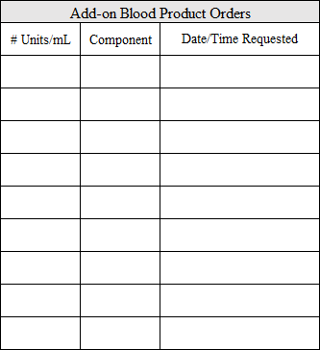
For Lab Use Only:

HLA Type: A , A B , B CPRA %:
Class I Antibodies:
BBA 006 05/19/23

